NAME: S. DHARANI
REG NO: 192472364
COURSE CODE: DSA0401
NUMPY / PANDAS ANALYSIS – QUESTIONS AND ANSWERS
QUESTION 14: CUSTOMER AGE FREQUENCY DISTRIBUTION
AIM:
To calculate the frequency distribution of customer ages using Pandas.
ALGORITHM:
1. Import Pandas.
2. Create a DataFrame containing customer ages.
3. Use value_counts() to count each age.
4. Sort the ages and display the frequency.
CODE:
import pandas as pd
df = pd.DataFrame({"Age": [20, 21, 20, 25, 21, 22, 20]})
frequency = df["Age"].value_counts().sort_index()
print(frequency)
INPUT:
Customer ages = [20, 21, 20, 25, 21, 22, 20]
OUTPUT:
Age
20 3
21 2
22 1
25 1
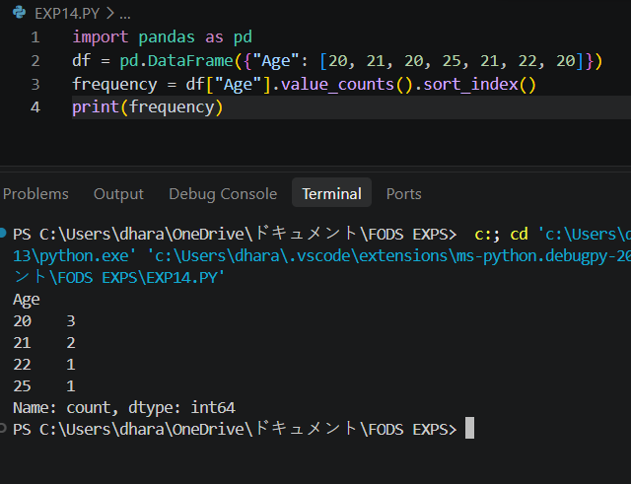
RESULT:
Customer age frequency distribution was calculated successfully.

